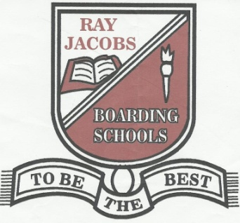
RAY JACOBS BOARDING SCHOOL (SECONDARY)
COLLEGE ROAD, P.O BOX 20, MGBIDI, ORU-WEST L.G.A
IMO STATE, NIGERIA
www.rayjacobsschool.com info@rayjacobsschool.com 08104955195

APPLICATION
FOR ADMISSION INTO JSS 1

A recent passport photograph of applicant

- APPLICANT’S INFORMATION

Full name of applicant:
Surname Other names

Address:
Street City

LGA State

Date of Birth: Age:
dd/mm/yyyy

Number of siblings: Applicant’s Ordinal Position:

Applicant’s Present School:
Address:
Street City

LGA State
Headmaster: Phone:

- PARENT/GUARDIAN INFORMATION
Father’s Full Name:
Title Surname Other names

Address:
Street City

LGA State
Phone: Email:

Occupation: Position:
Employer:
Work Address:
Street City

Mother’s Full name:
Surname Other names
Address:
Street City

LGA State
Phone: Email:
Occupation: Position:
Employer:
Work Address:
Street City

Guardian’s Full name:
Surname Other names

Address:
Street City

LGA State
Phone: Email:
Occupation: Position:
Employer:
Work Address:

With whom is the applicant living:

- OTHER INFORMATION
List relatives who have attended Ray Jacobs Primary School Relationship to Applicant

How did you hear about Ray Jacobs Boarding School?

Please describe the applicant’s characteristics, personality and interests.

Ray Jacobs Boarding School ……to be the best…….

